Code Refactoring – Improving Legacy Code with AI
Hall Ticket Number: 2303A51257
Assignment: 13.5

Task 1: Remove Repeated Code
Code:
# Legacy Code
a = [10, 20, 30, 40]
sum = 0
for i in a:
sum = sum + i
print("Sum:", sum)
avg = 0
for i in a:
avg = avg + i
avg = avg / len(a)
print("Average:", avg)
# Refactored Code
numbers = [10, 20, 30, 40]
total = sum(numbers)
average = total / len(numbers)
print("Sum:", total)
print("Average:", average)
Expected output :
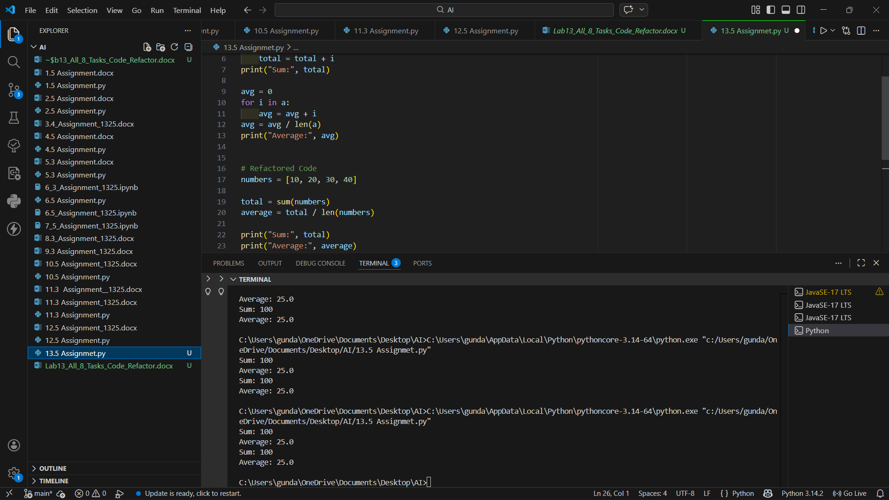
Conclusion:
Refactored code removes duplicated loops using Python built‑in functions which improves readability and reduces repetition.

Task 2: Improve Variable Naming
Code:
# Legacy Code
a = [5, 10, 15]
s = 0
for x in a:
s += x
print(s)
# Refactored Code
numbers = [5, 10, 15]
total_sum = 0
for number in numbers:
total_sum += number
print("Total Sum:", total_sum)
Expected output :
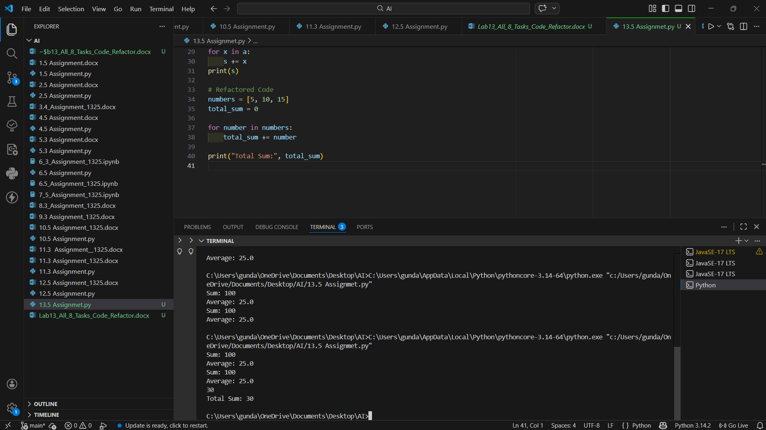
Conclusion:
Meaningful variable names improve code readability and make the program easier to understand and maintain.

Task 3: Use Functions
Code:
# Legacy Code
n = 5
fact = 1
for i in range(1, n+1):
fact = fact * i
print("Factorial:", fact)
# Refactored Code
def factorial(n):
result = 1
for i in range(1, n+1):
result *= i
return result
print("Factorial:", factorial(5))
Expected output :
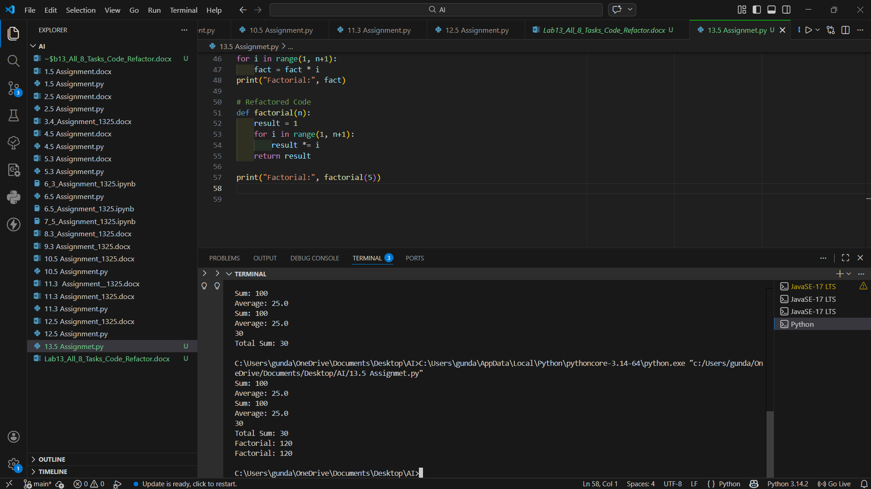
Conclusion:
Using functions improves modularity and allows code reuse, making programs easier to maintain.

Task 4: List Comprehension
Code:
# Legacy Code
squares = []
for i in range(1, 6):
squares.append(i*i)
print(squares)
# Refactored Code
squares = [i*i for i in range(1,6)]
print(squares)
Expected output :
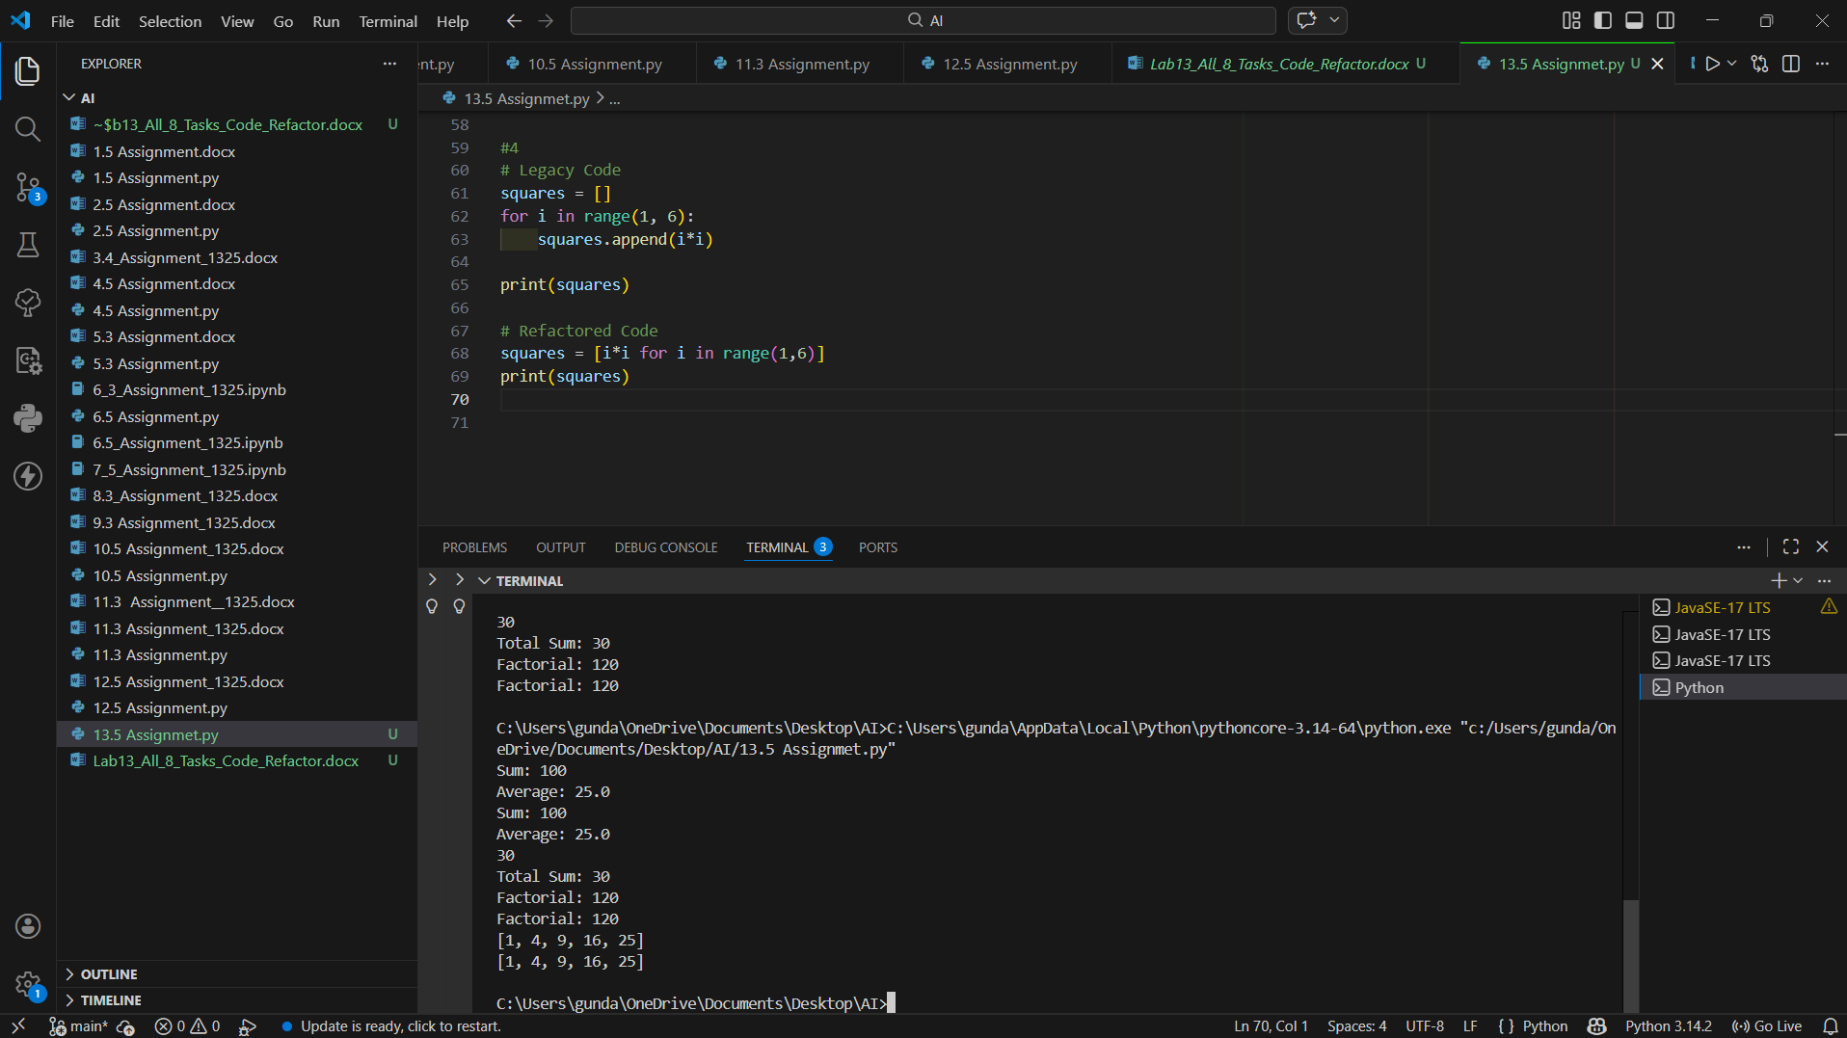
Conclusion:
List comprehension provides a shorter and more Pythonic way to create lists.

Task 5: Built‑in Functions
Code:
# Legacy Code
numbers = [3, 7, 2, 9, 5]
largest = numbers[0]
for n in numbers:
if n > largest:
largest = n
print("Largest:", largest)
# Refactored Code
numbers = [3, 7, 2, 9, 5]
largest = max(numbers)
print("Largest:", largest)
Expected output :
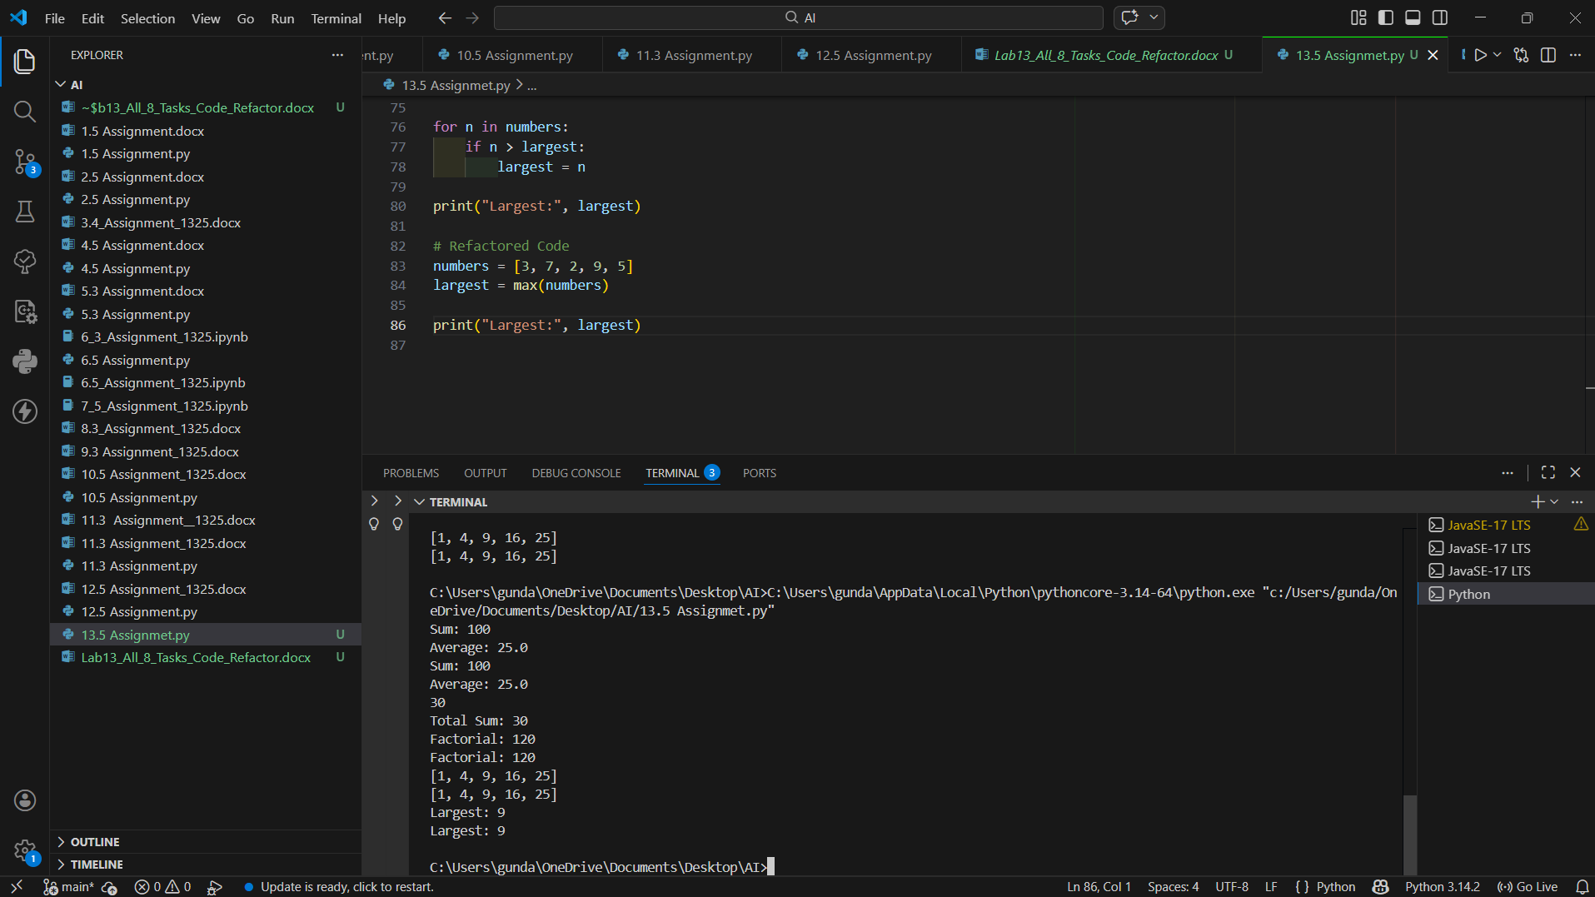
Conclusion:
Using built‑in functions like max() simplifies the code and improves efficiency.

Task 6: Error Handling
Code:
# Legacy Code
num = int(input("Enter number: "))
result = 10 / num
print(result)
# Refactored Code
try:
num = int(input("Enter number: "))
result = 10 / num
print("Result:", result)
except ZeroDivisionError:
print("Cannot divide by zero")
except ValueError:
print("Invalid input")
Expected output :
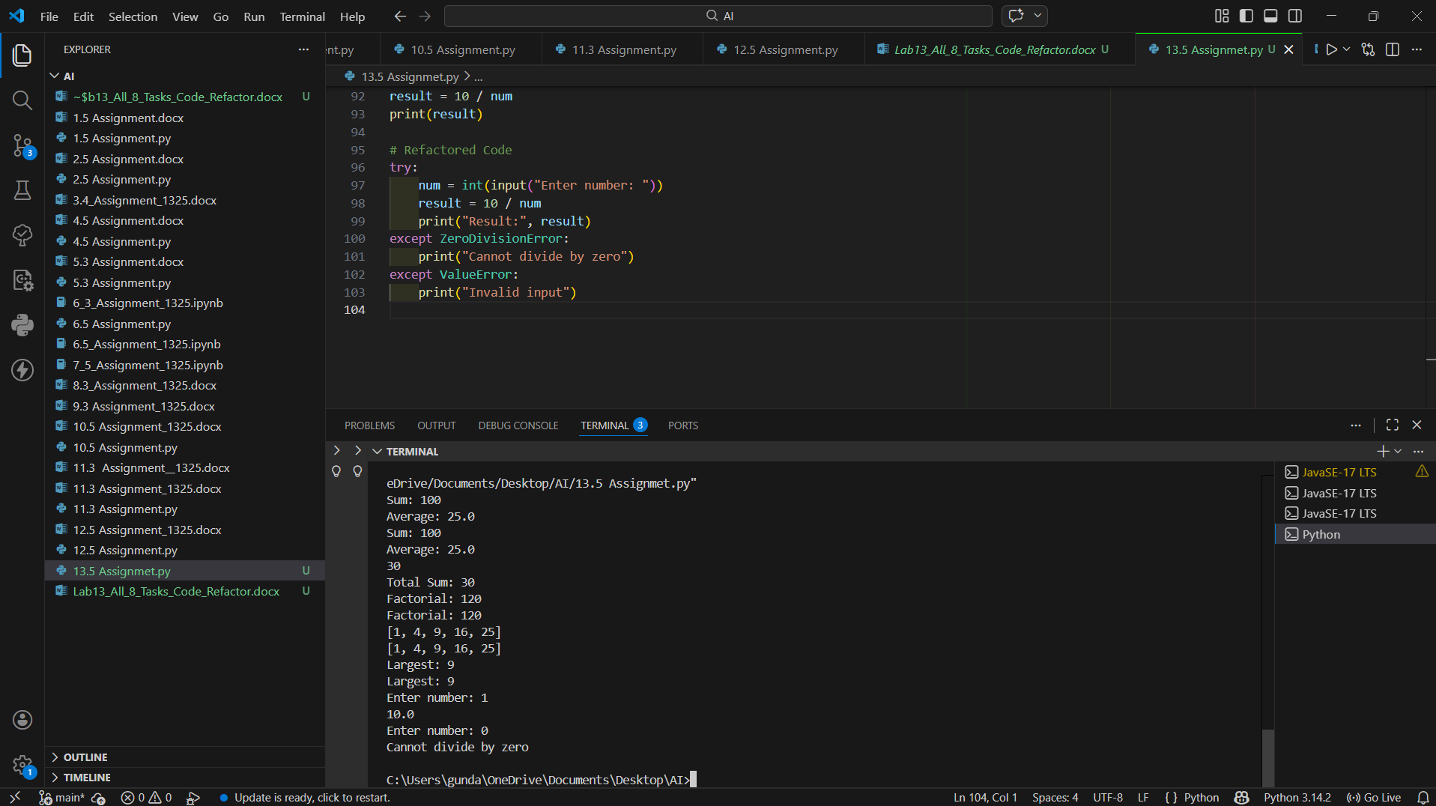
Conclusion:
Exception handling prevents program crashes and makes the application more robust.

Task 7: Avoid Global Variables
Code:
# Legacy Code
x = 10
def add():
global x
x = x + 5
print(x)
add()
# Refactored Code
def add(x):
return x + 5
result = add(10)
print(result)
Expected output :
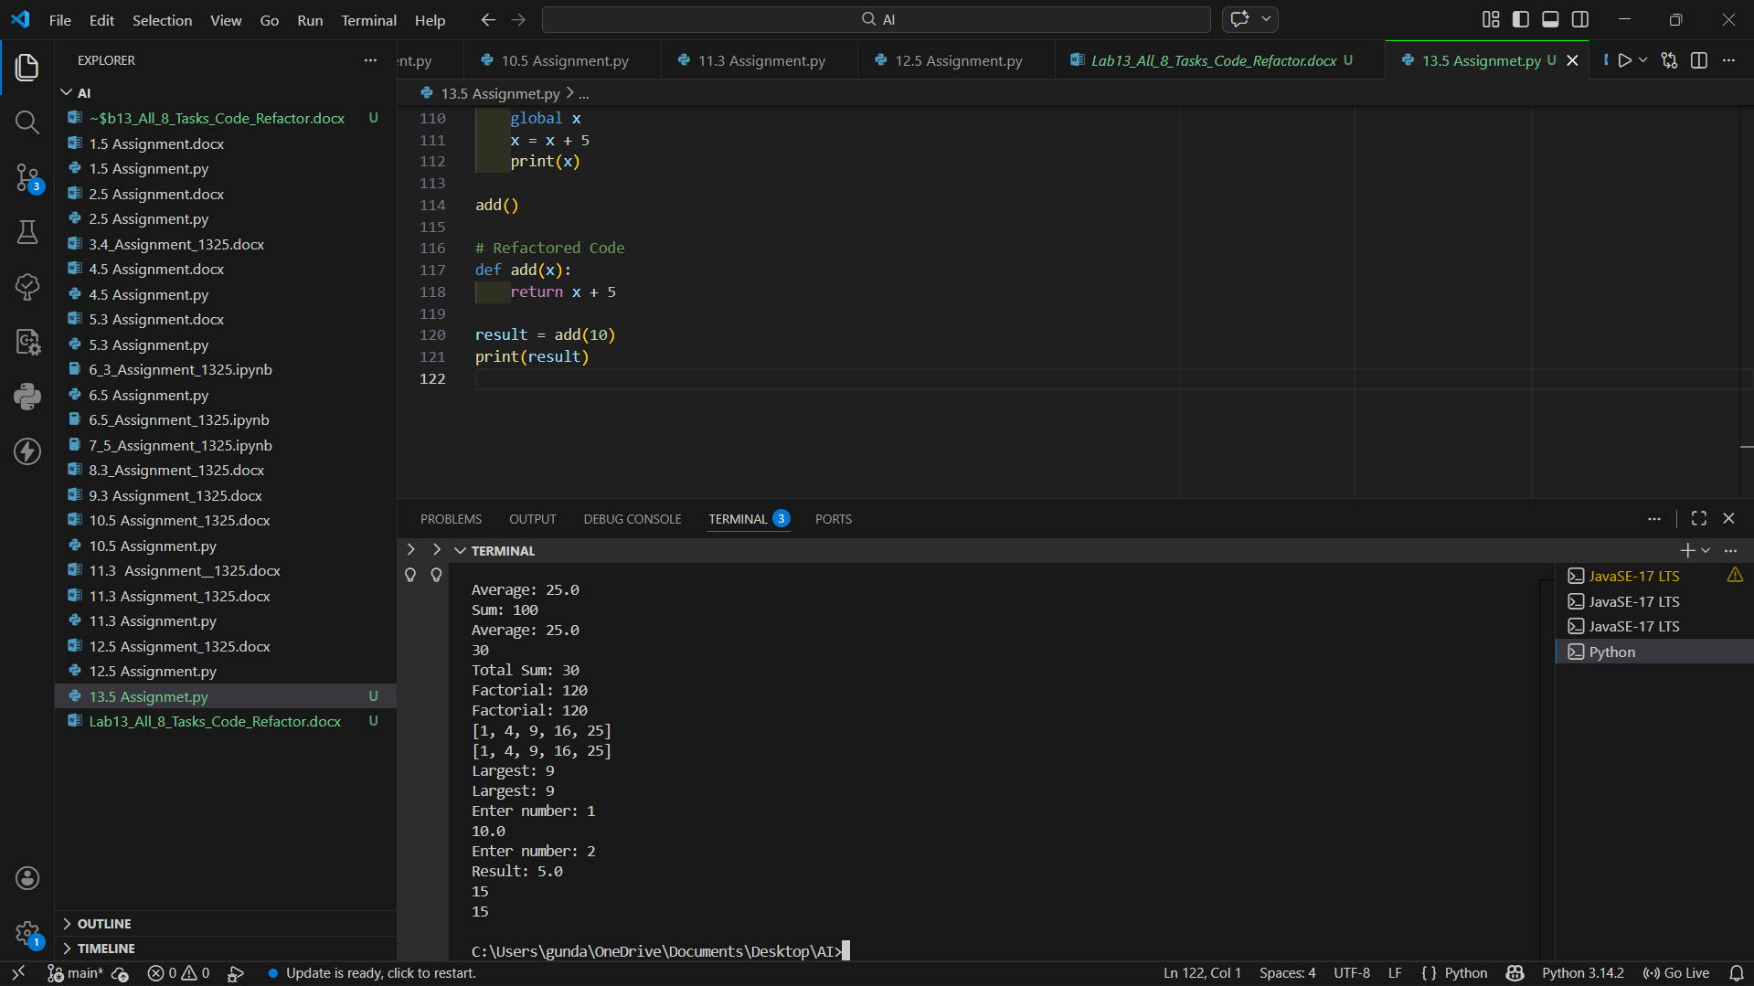
Conclusion:
Avoiding global variables improves code reliability and makes functions reusable.

Task 8: Optimize Loop Logic
Code:
# Legacy Code
numbers = [1,2,3,4,5,6,7,8,9,10]
even = []
for n in numbers:
if n % 2 == 0:
even.append(n)
print(even)
# Refactored Code
numbers = [1,2,3,4,5,6,7,8,9,10]
even_numbers = list(filter(lambda x: x % 2 == 0, numbers))
print(even_numbers)
Expected output :
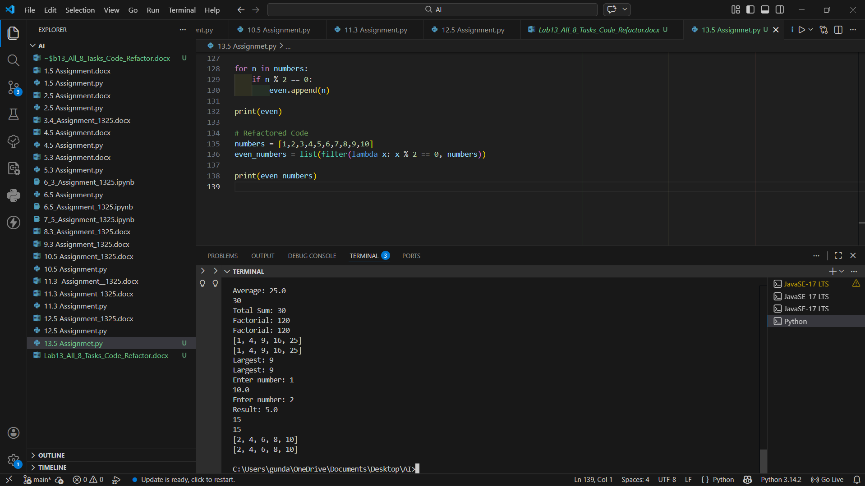
Conclusion:
Using functional methods like filter() produces concise and readable code.

